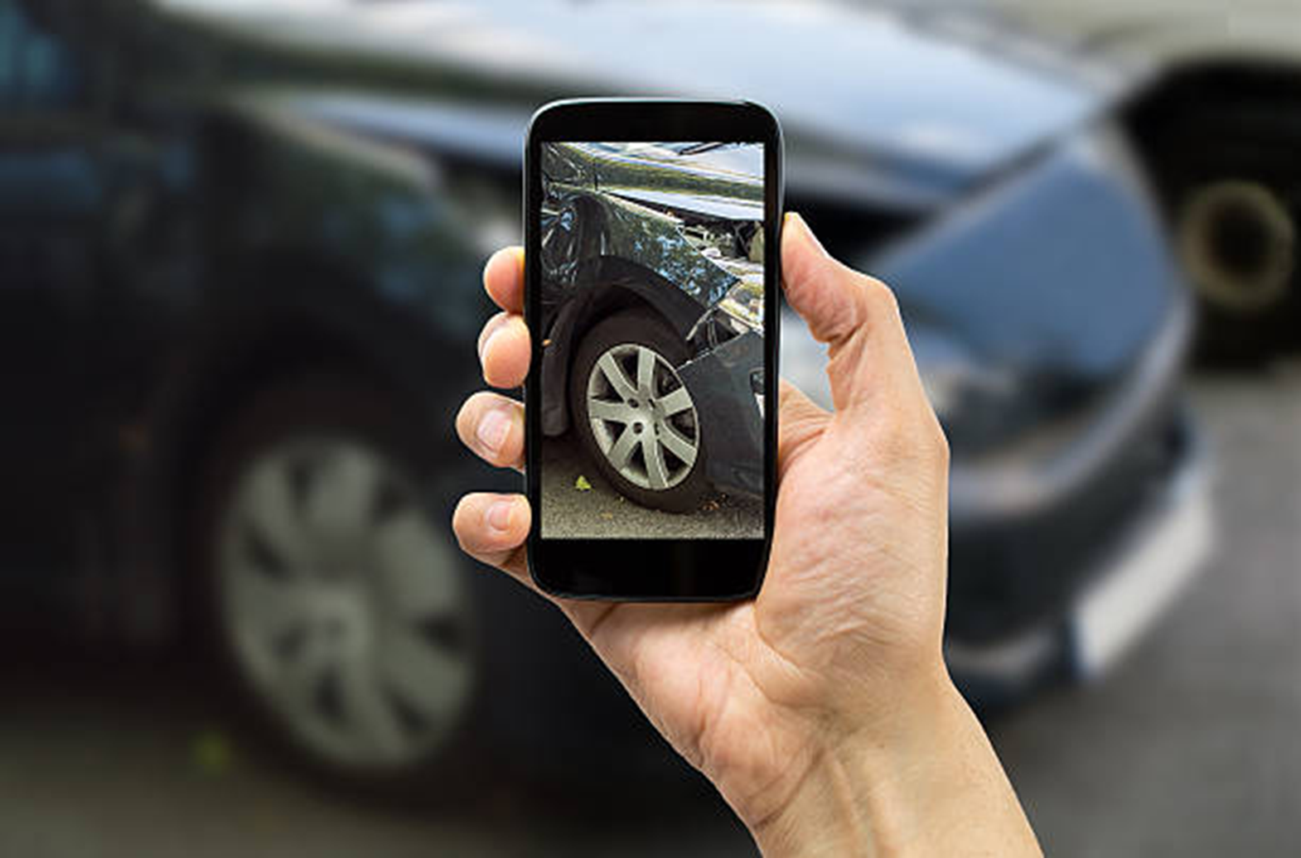

**Address:** Bryn Cefni Industrial Estate, Llangefni, Anglesey, LL77 7XA

Tel: 01248 750 989 Fax: 01248 751153

Email: [info@bartonandnichols.co.uk](mailto:info@bartonandnichols.co.uk)

FIND US ON GOOGLE MAPS

Established in 1996, we are the premier choice of repairers for North Wales. Approved and recognised by leading insurance companies and accident management companies, alike, we have achieved and maintained **The** **British Standard for the Repair of Accident Damaged Vehicles**, since its introduction in 2007.

**Address:** Bryn Cefni Industrial Estate, Llangefni, Anglesey, LL77 7XA

**Tel:** 01248 750 989 | **Fax:** 01248 751 153

**Email:** info@bartonandnichols.co.uk

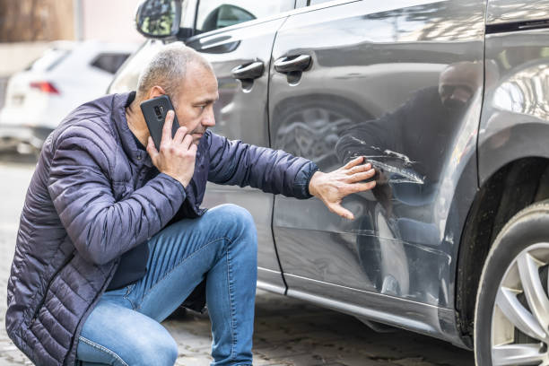

**Engineering Excellence**

We are vehicle body repair specialists, from the smallest scratch to major structural damage

🗸

**Customer Service**

From reception to delivery, our staff are trustworthy and client focussed, no matter your issue

🗸

**Efficient and Effective**

We employ the latest technology to ensure the minimum Key-to-Key time

🗸

**Have you been involved in an Accident or Collision?**

Call us to book an Assessment or Repair 01248 750 153

Established in 1996, Andy Barton, Carl Nichols and their team of Highly Skilled Body Repair Technicians, have a wealth of Skills and Experience. So when it comes to the Engineering Excellence required to reinstate an accident damaged vehicle, they are second to none. When it comes to First Class Customer Service, they are way ahead of the game

We offer a professional and friendly service for all your vehicle body repair needs. No Matter if you’re a domestic vehicle owner, an individual business user or a commercial fleet operator, we are here to help with your claim and your repair

**CONTACT US**

WHY CHOOSE US?

People are free to make their choice, but we pride ourselves on quality of our work and our customer services, and THAT’S why they choose

**Barton and Nichols**

Barton and Nichols Ltd

The Motor Body Repair Centre